Ver2024.7
Model No.: INLUX SafeCharge PCV-110

Product Technical Manual
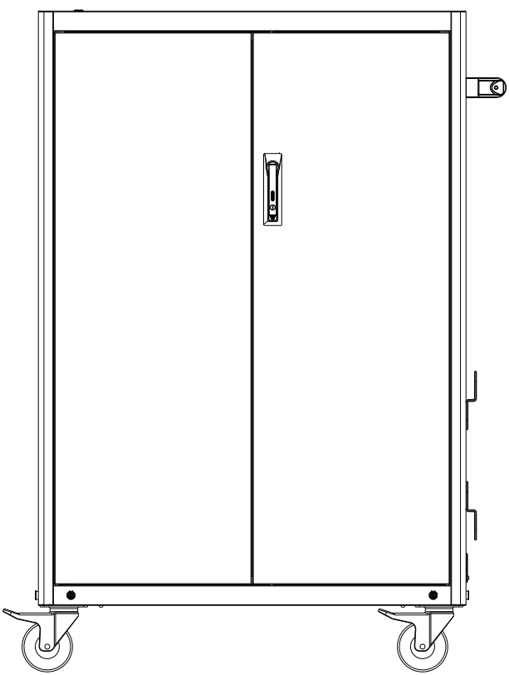

Catalogue

Safety Guidance 3
Product Introduction 6
Operation Instructions 7
Split Handrail Installation Instructions 9
Power Manager Detailed Description 10
Parameters 11

Safety Guidance
  - Please read these safety instructions carefully.
  - Please keep this user manual for future reference.
  - Please place the device on a stable and reliable platform before installation.
  - Before you connect the device to the power supply, make sure that the power voltage meets the standard, input voltage 100-240V.
  - Class I structure equipment (usually equipped with a three-core power cord, which needs to be grounded) should be connected to a grid power output socket with protective grounding.
  - Before installation, commissioning, and maintenance, the power supply must be disconnected before entering the product.
  - Never allow liquid to flow into the opening of the device, such behavior may cause fire or electric shock.
  - Please keep the device dry. Rainwater, moisture and various liquids or moisture may contain minerals that corrode the surface and circuits. If the device is accidentally wet, please immediately disconnect the power supply and wipe or blow dry.
  - Please avoid using the device in dusty, dirty places or such places. Movable parts and electronic components may be more easily damaged.
  - Do not place the device in high temperature. High temperatures may shorten the life of electronic devices and cause some plastic parts to deform or melt.
  - Do not place the device in a cold place. When the device heats up to its normal temperature, moisture may be generated inside it, damaging circuit boards or other electronic devices.
  - Do not knock or shake the device. Rough use may damage the internal circuit boards or precision structures.
  - Do not use irritating chemicals, cleaning solvents or corrosive detergents to clean the device.
  - When there is a power outage or it is not used for a long time, unplug the power plug to cut off the power to prevent surge shock to the device through the power cord.
  - Do not overload the power socket connected to the device or extend the power cord, otherwise it may cause fire or electric shock.
  - During the installation and trial process, do not let any foreign objects fall into the device to prevent affecting the normal operation of the circuit or causing a short circuit of the parts to cause fire or electric shock.
  - If the device fails, please do not disassemble and repair it without authorization. You should immediately contact the local dealer service provider to solve the problem.
  - The power plug is the disconnect device of the device. The power plug should be easily unplugged.
  - Please use a soft, clean and dry cloth to clean the surface of the device.
  - Please use the accessories or auxiliary parts provided or approved with the device. Other unauthorized accessories, especially electronic components, may damage the device circuit or movable parts.
  - Check the device regularly to ensure the stability of the device during use.
  - The above suggestions also apply to the accessories of this device and similar devices.
  - If the following situations occur, please have a full-time person check your device for you:
A. Liquid has penetrated into your device.
B. The device is exposed to moisture for a long time.
C. The device does not work properly or you cannot make the device work according to the description in the manual.
D. The device has fallen and is damaged; the device has obvious signs of damage.

Product Introduction

Dimensions

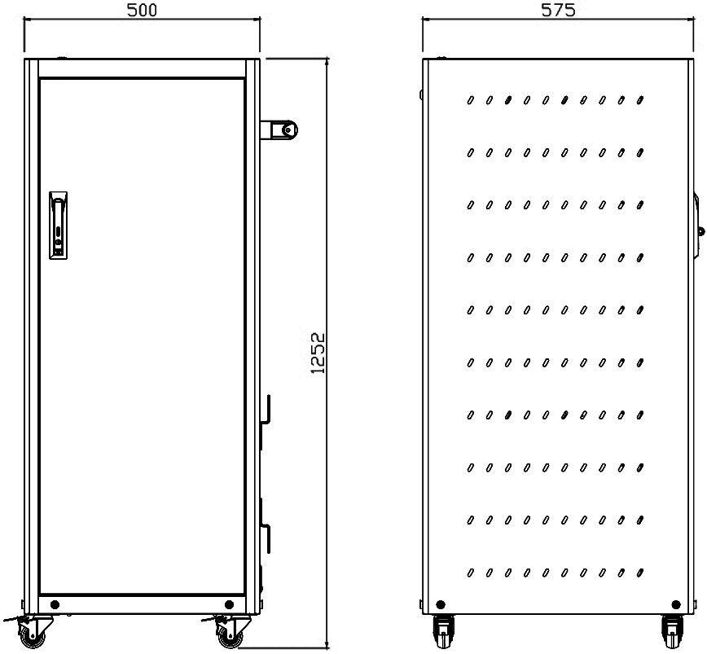

Overall size: 500*575*1252mm (this size does not include armrests, but includes wheels)
Product size is for reference only, the actual size is subject to factory delivery.

Functions and Interfaces
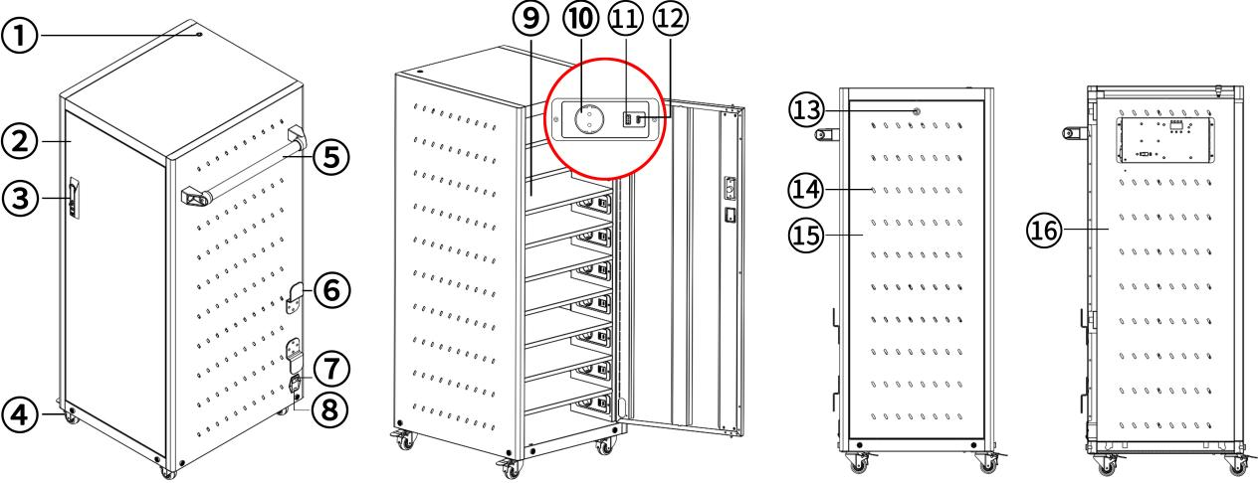
①System switch ② Front door of the charging cart (including charging compartment) ③ Door lock ④ 2-inch movable wheels ⑤ Handrail ⑥ Cable winding rack
⑦ Power input ⑧ Main power switch ⑨ Charging compartment
⑩ European standard power socket ⑪ USB-A ⑫ USB-C ⑬ Door lock
⑭ Cooling hole ⑮ Inspection door (including power management compartment, non-professionals should not open this door) ⑯ Power management compartment
Charging Method
This product has three charging methods: power socket, USB-A, and USB-C.
Power Management Mode
ON mode（Timing Mode）,CYC mode（Cycle Mode）,the factory default working mode is ON mode, with a timer of 600 minutes.
- Operation Instructions
Open/Close the front door lock
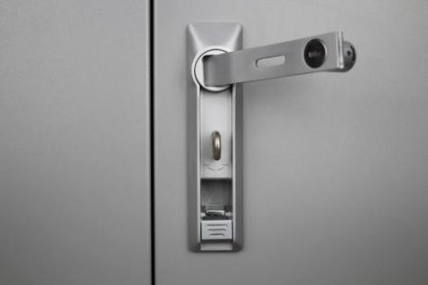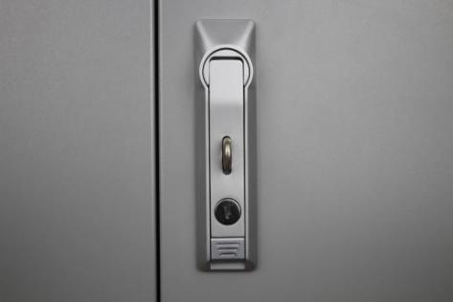
Open Close
Note: When closing the door, please adjust the door lock handle to the state shown in the "Open Door Lock" picture before closing the door, otherwise there will be obstacles above the door that affect closing the door.
Wheels Lock
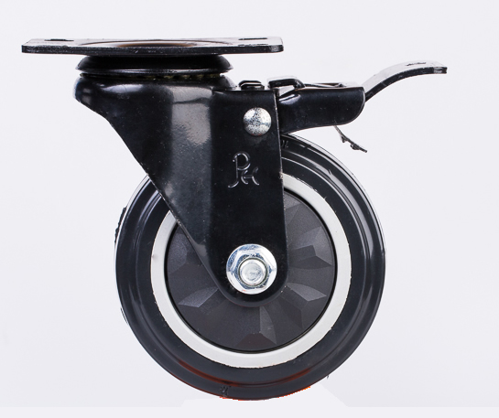
Push-down locking wheels Lift up to unlock the wheels
Insert Charging Device
Press the system switch, turn off the power of the charging car, unlock and open the front door of the charging car, connect the device to be charged with the charging cable, put it into the charging compartment, and put the charging cable away to avoid it being pinched. Press the system switch, observe that the device is charging normally, then close and lock the front door. Be sure to keep the key.
Remove the charging device
Press the system switch to power off the charging car, unlock and open the front door of the charging car, unplug the charging cable, and put the charging cable away to avoid being pinched, take out the charging equipment, close and lock the front door, and be sure to keep the key.

- Split Handrail Installation Instructions
(The screws have been pre-installed in the mounting holes and need to be removed before installing the handrail.)
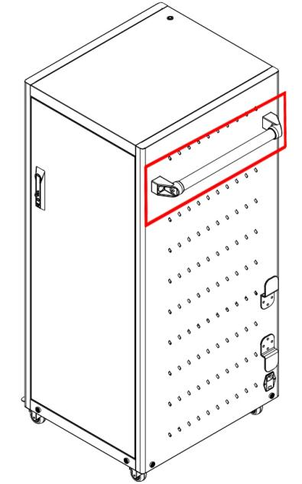
Place the armrest bracket on the corresponding armrest fixing hole of the charging cabinet.
Pass the adapter screw through the bracket screw hole to fix it to the box.
Pass the adapter screw through the armrest bracket hole to connect and fix the armrest.

- Power Manager Detailed Description
  - Model No.SP-SV442W Function
    - In ON mode (timing mode), after the sequential power supply is turned on, output sockets 1, 2, 3, and 4 are powered in sequence, and the digital tube displays a minute countdown. When the time is reduced to 0, sockets 1, 2, 3, and 4 are turned off in sequence.
    - In CYC mode (cycle mode), after the sequential power supply is turned on, output socket 1 starts to supply power, and the digital tube displays a minute countdown. When the time is reduced to 0, socket 1 is turned off and socket 2 is turned on. The digital tube time is reset and the countdown starts again, and it cycles in sequence.
  - Operation Instructions
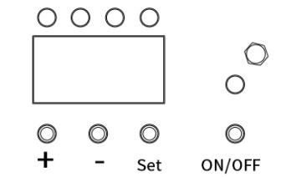
(All settings must be performed with the device powered off)
    - Press Set in the off state to enter the mode selection state, and the digital tube displays one of ON and CYC.In the mode selection state, press + to enter the ON mode (timing mode) or press - to enter the CYC mode (cycle mode).
    - Press Set in the ON display to enter the timing time setting. At this time, the digital tube displays flashing numbers. + is for adding minutes, and - is for subtracting minutes. The setting range is 000-999. When set to 000, the socket is in long power supply mode. Press Set again to exit the setting state. The digital tube displays the current timing time.
    - Press Set in the CYC display to enter the cycle digit selection state. The digital tube flashes. Press + or - to select the number of sockets participating in the cycle. For example, if it is set to 3: sockets 1 2 3 are cycled respectively. After the number of digits is selected, press Set again to enter the cycle interval time selection state. Press + and - to set the cycle interval time. The setting range is 00-99. After setting, press Set to exit the setting state.

- Parameters
Input |  | 100-240VAC 10A
AC Outlet Total Output |  | 100-240VAC 10A
USB Output | USB-A | 5VDC 3A 15W, 9VDC 2A 18W, 12VDC 1.5A 18W
USB Output | USB-C | 5VDC 3A 15W, 9VDC 2.22A 20V, 12VDC 1.67A 20W
USB Output | USB-A+USB-C | 5VDC 3.1Atotal,Max 15.5W

